- Install nginx and run nginx on port number 81.
Installation of nginx
Sudo yum update && yum install nginx
Systemctl start nginx
Systemctl enable nginx
Systemctl status nginx
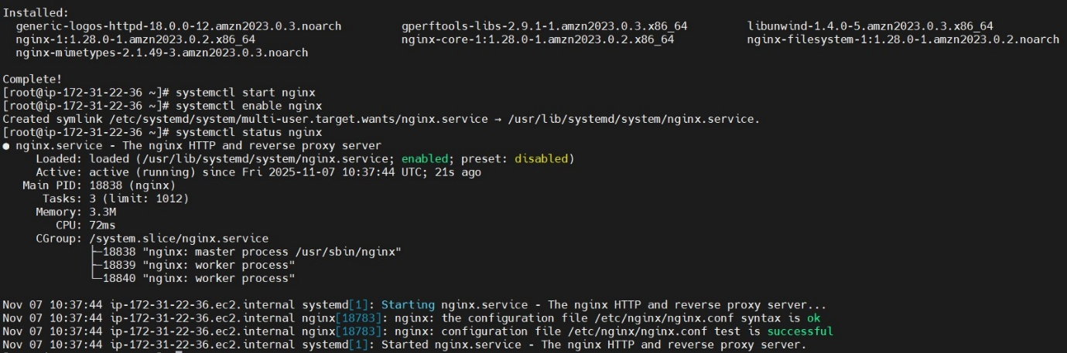

Using grep with 80 port number
Netstat -na | grep 80
lsof -I tcp:80

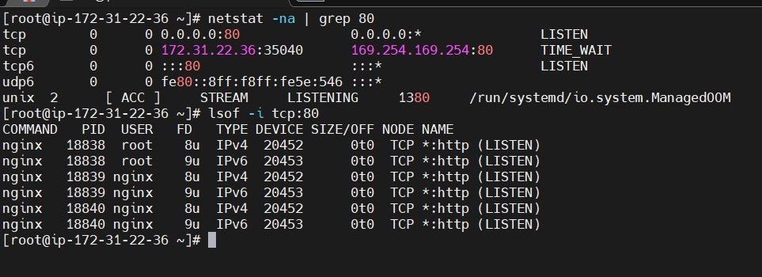
Changing port no to 81
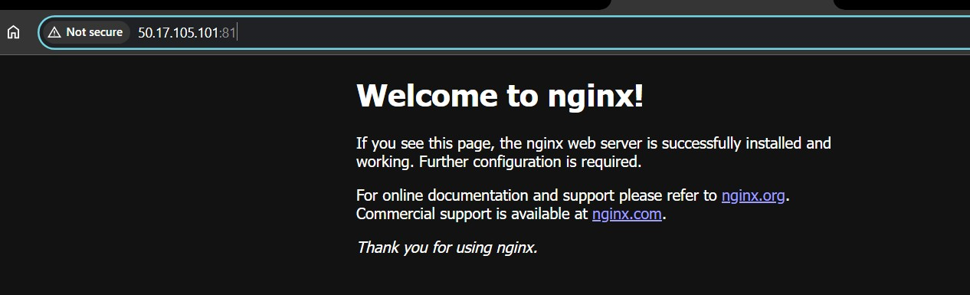

- Deploy a sample index.html file on nginx.
Go to the sample.index file in /usr/share/nginx/html and change the text in the <h1> welcome maninder <h1>
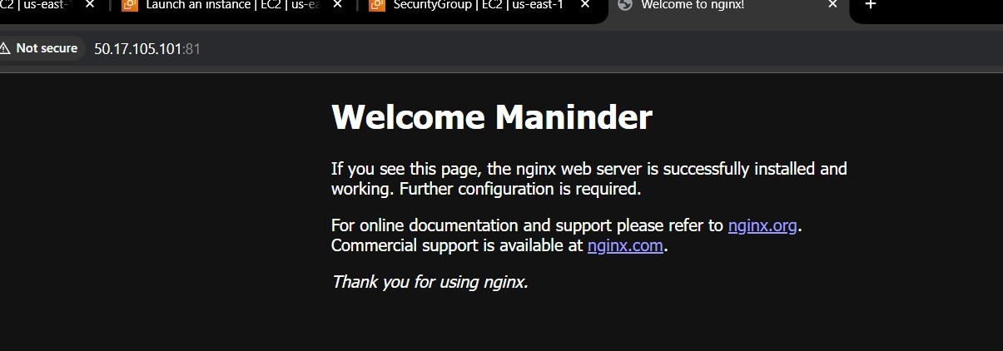

- Install Apache and run Apache on port number 82
- Installation of httpd
- Sudo yum update && yum install httpd
- Systemctl start httpd
- Systemctl enable httpd
- Systemctl status httpd
Go to /etc/httpd/conf/httpd.conf and change the listen to 82
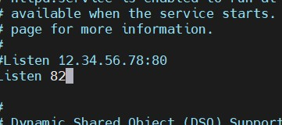
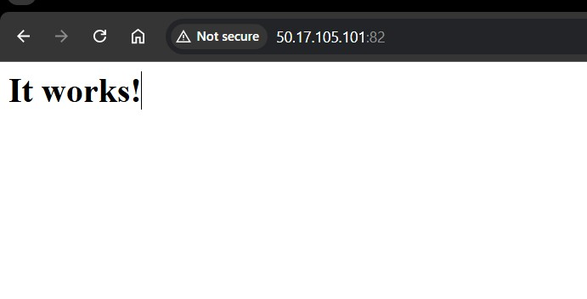
- Deploy a sample index.html file on Apache.
Go to /var/www/html/ and change the file to desired html content
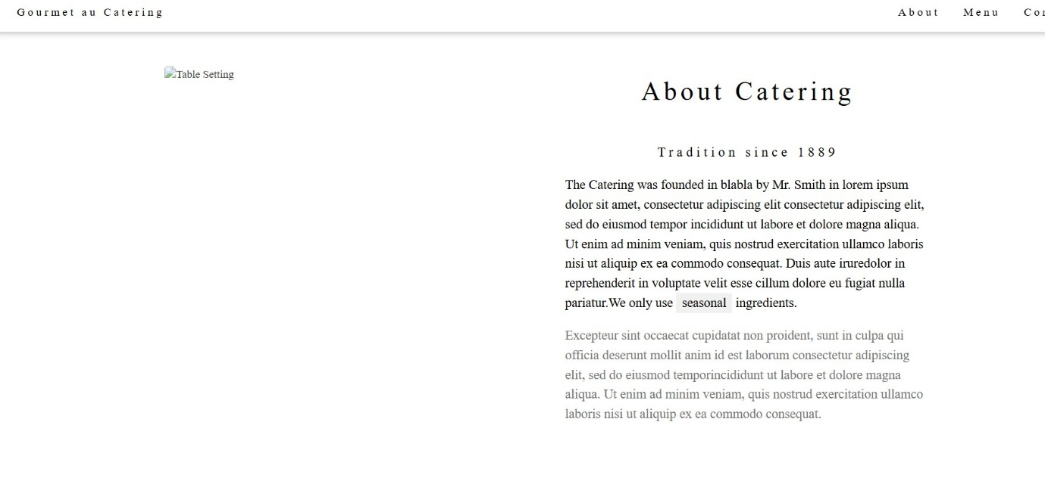

- Install Apache tomcat on port number 8082
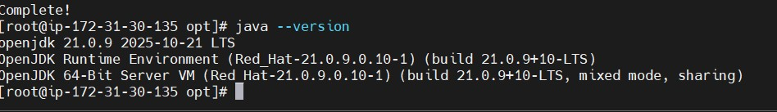
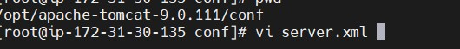
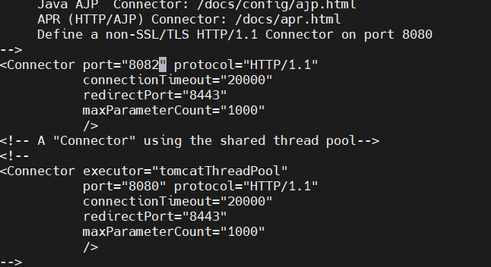
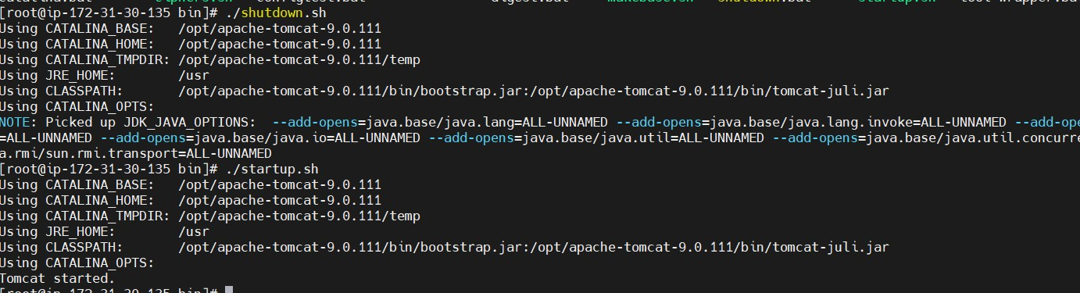
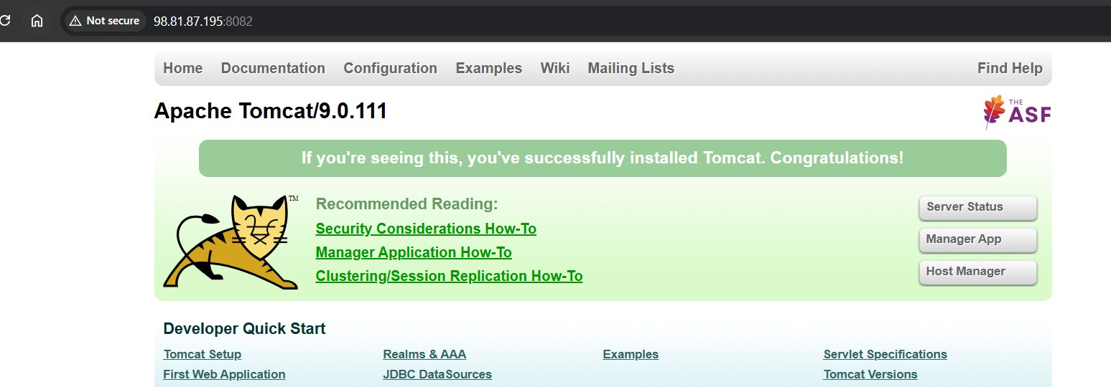

- Deploy a sample app on webapps

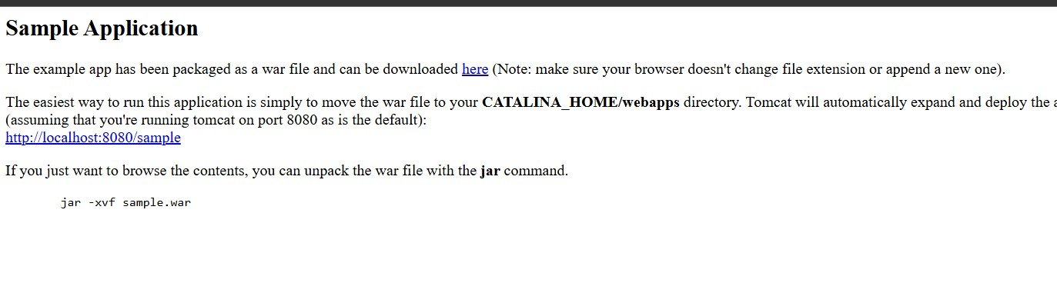
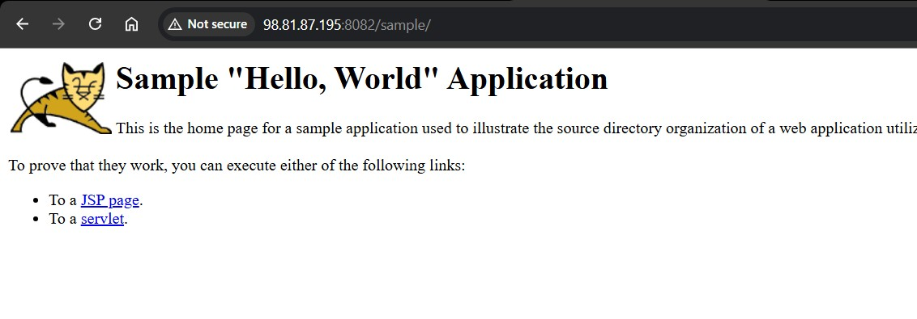
Steps: go to browser and search apache tomcat sample.war
#then copy link address
#go to <cd /opt/tomcat/webapps/>
# then wget URL
#go to browser paste your public ip:8082/sample.
- Create a tomcat.service file for tomcat.

cd opt
wget https://dlcdn.apache.org/tomcat/tomcat-9/v9.0.107/bin/apache-
tomcat-9.0.107.tar.gz
tar xvf tomcat.tar(extract file)
mv tomcat-file-name tomcat
chown -R ec2-user:ec2-user tomcat
chmod 777 /opt/tomcat/bin/startup.sh
chmod 777 /opt/tomcat/bin/ shutdown.sh
touch /etc/systemd/system/tomcat.service
vi tomcat.service(paste the code)
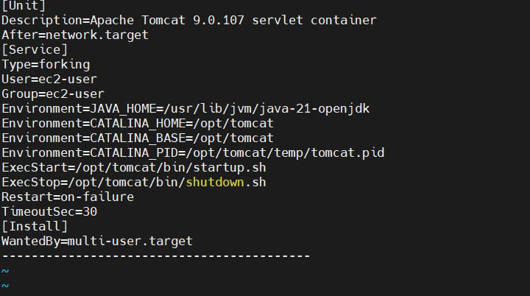

sh startup.sh
systemctl daemon-reload(to give daemon permissions)
systemctl status tomcat
systemctl start tomcat
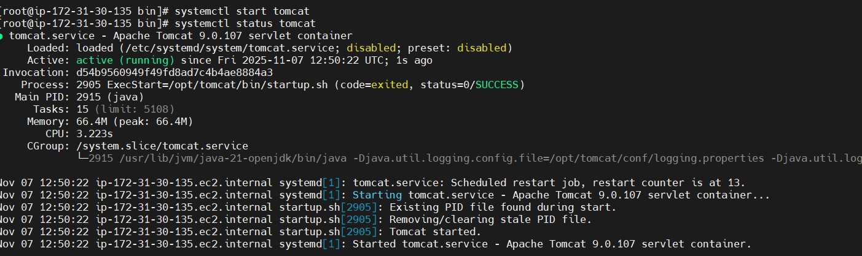

- Configure HA Proxy server
Server-1 nginx
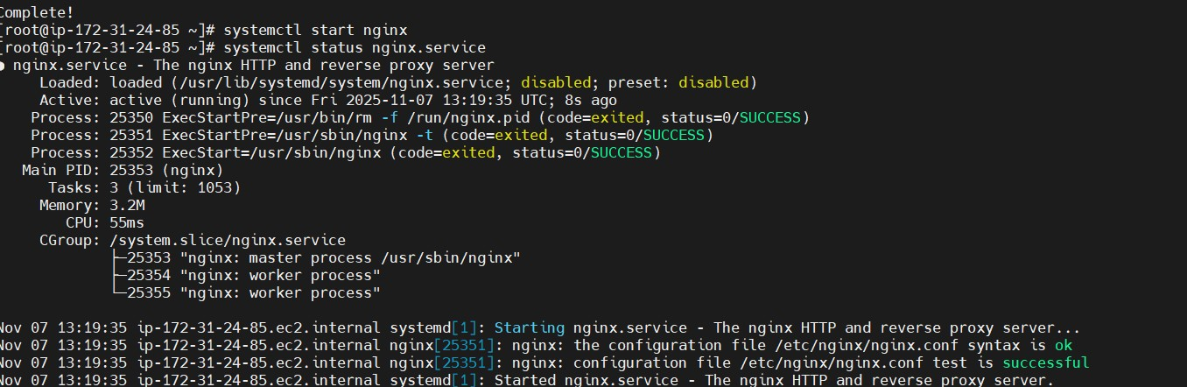

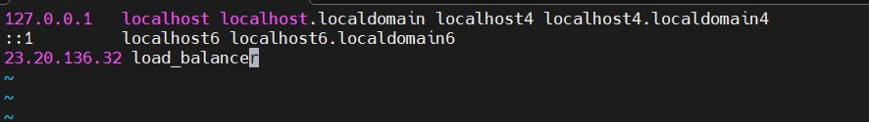
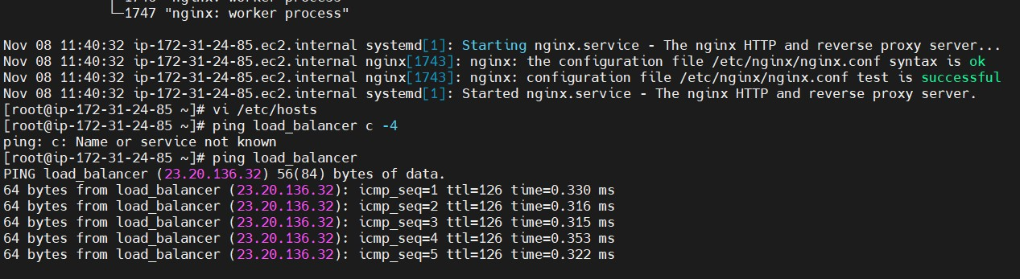

Server-2 httpd:
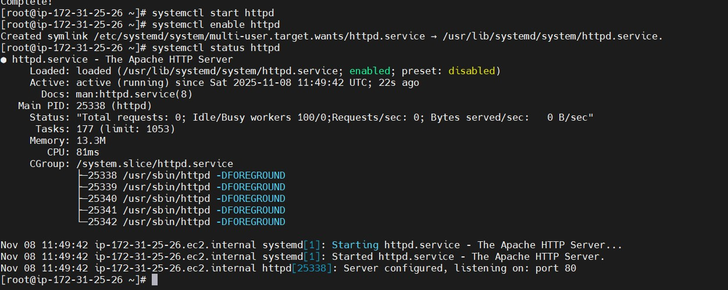

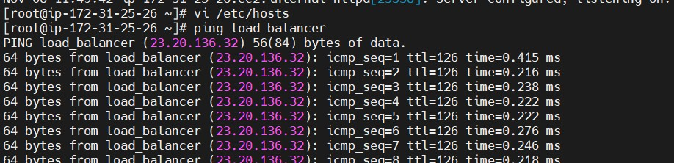

3. HA-Proxy-Server
